

**KERİM MORAL**

**518191043**

**Inverse Kinematic Solutions with Paden-Kahan SubProblems**

**for a Specified Robotic Platform**

**KOM 513E – Modelling and Control of Robots**

**Prof. Dr. Hakan TEMELTAŞ**

Contents

1. Introduction 2

2. Calculation of Inverse Kinematics 3

Solving $θ1$ 3

Solving $θ3$ 4

Solving $θ2$ 5

Solving $θ4$ and $θ5$ 5

Solving $θ6$ 6

3. GUI Design and Simulations on RoboDK 7

## Introduction

The purpose of this project is to find all kinematic solutions of a GSK-RB20 robotic arm with Paden-Kahan sub problems. Robotic arm can be seen on Figure 1.

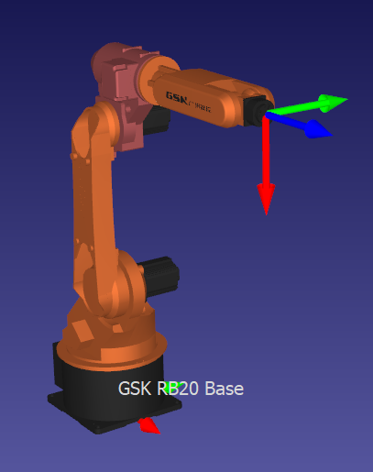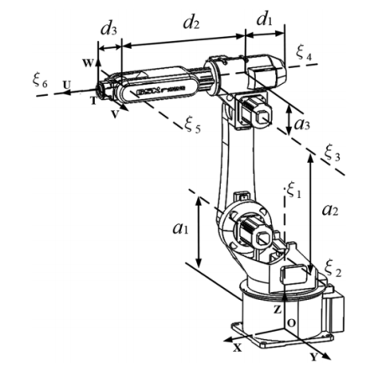

Figure 1 GSK-RB20 Robotic Arm

A GUI has been designed in order for user to enter either one example angle set for all six joints, or a homogenous transformation matrix for desired end-point configuration. This GUI can be seen on Figure 2.

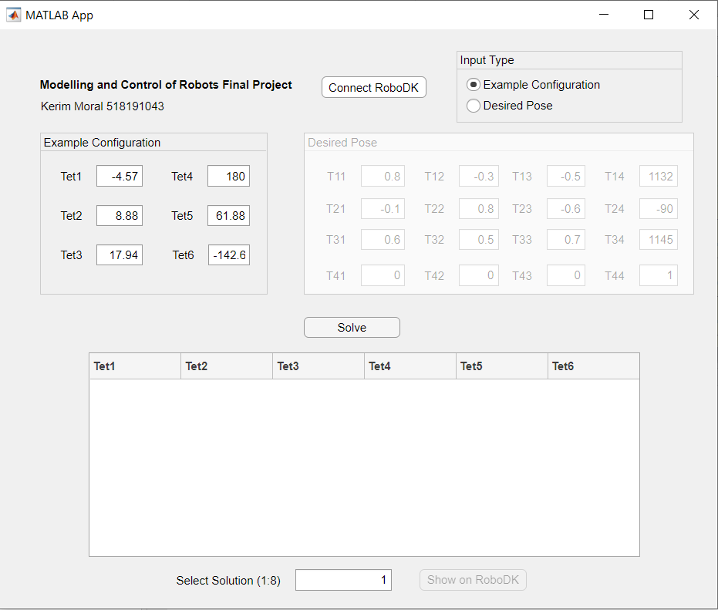

Figure 2 GUI

## Calculation of Inverse Kinematics

## Solving $θ_{1}$

Robot parameters for calculating desired joint angles can be seen on Figure 1. First, desired configuration matrix has to be found in order to solve IK.

Skrews S1, S2, S3, S4, S5 and S6 have to be calculated in order to achieve Transformation Matrix. And in order to calculate Skrews linear velocities corresponding to that skrew axes have to be calculated.

$w_{6}=\left[\begin{matrix}1 \\ 0 \\ 0\end{matrix}\right]$, $q_{6}=q_{4}$ $w_{5}=\left[\begin{matrix}0 \\ 1 \\ 0\end{matrix}\right]$, $q_{5}=q_{4}$

$w_{4}=\left[\begin{matrix}1 \\ 0 \\ 0\end{matrix}\right]$, $q_{4}=\left[\begin{matrix}d_{1}+d_{2} \\ 0 \\ a_{1}+a_{2}+a_{3}\end{matrix}\right]$ $w_{3}=\left[\begin{matrix}0 \\ 1 \\ 0\end{matrix}\right]$, $q_{3}=\left[\begin{matrix}d_{1} \\ 0 \\ a_{1}+a_{2}\end{matrix}\right]$

$w_{2}=\left[\begin{matrix}0 \\ 1 \\ 0\end{matrix}\right]$, $q_{2}=\left[\begin{matrix}d_{1} \\ 0 \\ a_{1}\end{matrix}\right]$ $w_{1}=\left[\begin{matrix}0 \\ 0 \\ 1\end{matrix}\right]$, $q_{1}=\left[\begin{matrix}0 \\ 0 \\ 0\end{matrix}\right]$

And corresponding linear velocities and Screws:

$v_{i}=-w_{i}xq_{i}$,

$S_{i}=[w_{i}{ v}_{i}]'$ where $i=0,1…6$

Home position M which can be seen on Figure 1 is

$R=\left[\begin{matrix}1 & 0 & 0 \\ 0 & 1 & 0 \\ 0 & 0 & 1\end{matrix}\right]$, $q_{0}=\left[\begin{matrix}d_{1}+d_{2}+d_{3} \\ 0 \\ a_{1}+a_{2}+a_{3}\end{matrix}\right]$, $M=\left[\begin{matrix}R & q0 \\ 0 & 1\end{matrix}\right]$

Skew of screws are needed to calculate Transformation Matrix. A Matlab function has been written in order to get skews:

|  |
| --- |
| function skew_matrix = skew(w)  skew_matrix = [0 -w(3) w(2);...  w(3) 0 -w(1);...  -w(2) w(1) 0];  end |

And finally desired Transformation matrix is:

$Td= e^{\left[S1\right]θ_{1d}}e^{\left[S2\right]θ_{2d}}e^{\left[S3\right]θ_{3d}}e^{\left[S4\right]θ_{4d}}e^{\left[S5\right]θ_{5d}}.M$

Where $θ_{1d}$ to $θ_{6d}$ are example desired angles input from GUI.

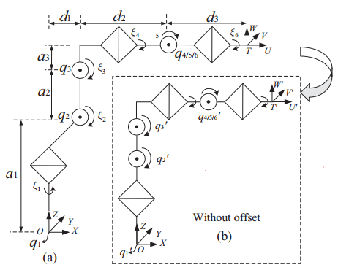

Figure Points and Distances of Platform

As can be seen from Figure 3, q4=q5=q6= $q_{4,5,6}$ is the intersection point of axes S4, S5, S6. For that reason

$Td.M^{-1}.\overline{q_{4,5,6}}=\exp\left(S1.θ_{1}\right).\exp\left(S2.θ_{2}\right).\exp\left(S3.θ_{3}\right).\overline{q_{4,5,6}}$ (1)

Let $p_{1}=Td.M^{-1}.\overline{q_{4,5,6}}$

As can be seen from Figure 3, rotational angle of $\overline{q_{4,5,6}}$ is directly equal to $θ_{1}$. So

$θ_{1}=atan2(±{p_{1}}_{y},±{p_{1}}_{x})$

## Solving $θ_{3}$

With current configuration, due to d1 offset it is not possible to find all joints with traditional PK sub problems. Because of that, a new configuration has to be found. In order to eliminate that offset, a new translation matrix is introduced

$T_{t}=\left[\begin{matrix}1 & 0 & 0 & -d_{1}\cos{θ_{1}} \\ 0 & 1 & 0 & -d_{1}\sin{θ_{1}} \\ 0 & 0 & 1 & 0 \\ 0 & 0 & 0 & 1\end{matrix}\right]$ (2)

New axis points after transformations are

$q_{1}^{'}={\left[0 0 0\right]}^{'}, q_{2}^{'}={\left[0 0 a_{1}\right]}^{'}$

$q_{3}^{'}={\left[0 0 a_{1}+a_{2}\right]}^{'}, q_{4}^{'}=q_{5}^{'}=q_{6}^{'}={\left[d_{2} 0 a_{1}+a_{2}+a_{3}\right]}^{'}$

And new home position

$M^{'}=\left[ \begin{matrix}1 & 0 & 0 & d_{2}+d_{3} \\ 0 & 1 & 0 & 0 \\ 0 & 0 & 1 & a_{1}+a_{2}+a_{3} \\ 0 & 0 & 0 & 1\end{matrix}\right]$ (3)

Substituting (2) to (1)

$Tt.Td.M^{-1}.\overline{q_{4,5,6}^{'}}=\exp\left(S1.θ_{1}\right).\exp\left(S2.θ_{2}\right).\exp\left(S3.θ_{3}\right).\overline{q_{4,5,6}^{'}}$ (4)

Let $p_{2}=Tt.Td.M^{-1}.\overline{q_{4,5,6}^{'}}$

If we take norm after subtracting an intersection point

$\exp\left(S1.θ_{1}\right).\exp\left(S2.θ_{2}\right).[exp\left(S3.θ_{3}\right).\overline{q_{4,5,6}^{'}}-\overline{q_{2}^{'}}]=\overline{p_{2}}-\overline{q_{2}^{'}}$

Distance between $\overline{q_{4}^{'}}$ and $\overline{q_{2}^{'}}$ doesn’t depend on S1 and S2 axis, after taking norm

$||exp\left(S3.θ_{3}\right).\overline{q_{4,5,6}^{'}}-\overline{q_{2}^{'}}||=\overline{||p_{2}}-\overline{q_{2}^{'}}||$

We define r3 as a point on the axis x3, where

$r_{3}=[0 0 a_{1}+a_{2}]'$

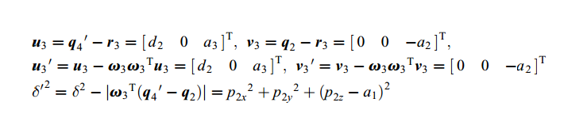Now $θ_{3}$ can be calculated with PK subproblem 3.

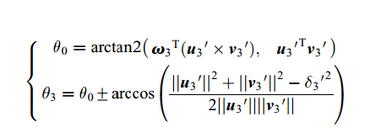

## Solving $θ_{2}$

Since now $θ_{1}$ known, by multiplying both sides with inverse of S1 transformation;

$\exp\left(-S1.θ_{1}\right).Tt.Td.{M'}^{-1}.\overline{q_{4,5,6}^{'}}=\exp\left(S2.θ_{2}\right).\exp\left(S3.θ_{3}\right).\overline{q_{4,5,6}^{'}}$

$θ_{3}$ is also known

$\exp\left(-S1.θ_{1}\right).Tt.Td.M^{-1}.\overline{q_{4,5,6}^{'}}=\exp\left(S2.θ_{2}\right).\overline{q_{7}^{}}$

Where $\overline{q_{7}^{}}= \exp\left(S3.θ_{3}\right).\overline{q_{4,5,6}^{'}}$

Define p3 as

$p_{3}=\exp\left(-S1.θ_{1}\right).Tt.Td.M^{-1}.\overline{q_{4,5,6}^{'}}$

So

$p_{3}= \exp\left(S2.θ_{2}\right).\overline{q_{7}^{}}$

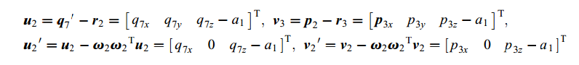Now $θ_{2}$ can be solved with PK subproblem 1.



## Solving $θ_{4}$ and $θ_{5}$

With known angles, equation (4) can be further reduced to

$\exp\left(-S3.θ_{3}\right).exp\left(-S2.θ_{2}\right).exp\left(-S1.θ_{1}\right).Tt.Td.{M'}^{-1}=\exp\left(S4.θ_{4}\right).exp\left(S5.θ_{5}\right)$ (5)

$q_{6}''$ point is defined such as it is on the S6 axis but not intersecting with the S5 axis where

$q_{6}^{''}=[0 0 a_{1}+a_{2}+a_{3}]'$

With multiplying (15) with $q_{6}^{''}$

$\exp\left(-S3.θ_{3}\right).exp\left(-S2.θ_{2}\right).exp\left(-S1.θ_{1}\right).Tt.Td.M^{-1}.q_{6}^{''}=\exp\left(S4.θ_{4}\right).exp\left(S5.θ_{5}\right).q_{6}^{''}$

Define p4 point as

$p_{4}=\exp\left(-S3.θ_{3}\right).exp\left(-S2.θ_{2}\right).exp\left(-S1.θ_{1}\right).Tt.Td.M^{-1}.q_{6}^{''}$

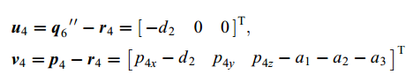Now $θ_{4}$ and $θ_{5}$ can be calculated with PK subproblem 2. For that and intersection point between S5 and S4 has to be defined

$r_{4}=[d_{2} 0 a_{1}+a_{2}+a_{3}]'$

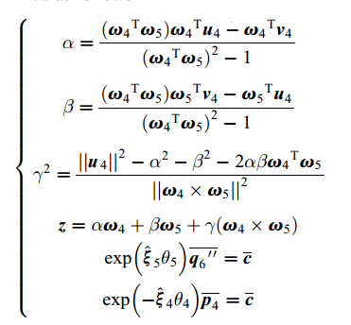

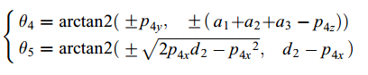

## Solving $θ_{6}$

After knowing $θ_{1}$- $θ_{5}$ equation (5) can be further reduced to

$\exp\left(-S5.θ_{5}\right).exp\left(-S4.θ_{4}\right).exp\left(-S3.θ_{3}\right).exp\left(-S2.θ_{2}\right).exp\left(-S1.θ_{1}\right).Tt.Td.{M'}^{-1}=\exp\left(S6.θ_{6}\right)$

Let $q_{8}^{}$ be a point out of S6 axis where $q_{8}^{}=\left[0 0 a_{1}+a_{2}\right]'$

$\exp\left(-S5.θ_{5}\right).exp\left(-S4.θ_{4}\right).exp\left(-S3.θ_{3}\right).exp\left(-S2.θ_{2}\right).exp\left(-S1.θ_{1}\right).Tt.Td.{M'}^{-1}.q_{8}^{}=p_{5}$

And r6 as a point on S6, $r_{6}=[0 0 a_{1}+a_{2}+a_{3}]'$

Now $θ_{6}$ can be solved with PK subproblem 1.





## GUI Design and Simulations on RoboDK

Same configuration as in the original paper has been tested in the designed GUI. After entering desired angles or final pose, GUI calculates and prints all configurations to the screen as on Figure 4. After connecting to RoboDK and hitting “Solve” button, all configurations are printed to screen. User now can select one of them and see configuration on RoboDK by hitting “Show on RoboDK” button. Except some offset caused from limits of RoboDK, simulation results are the same as paper. Two test cases can be seen on

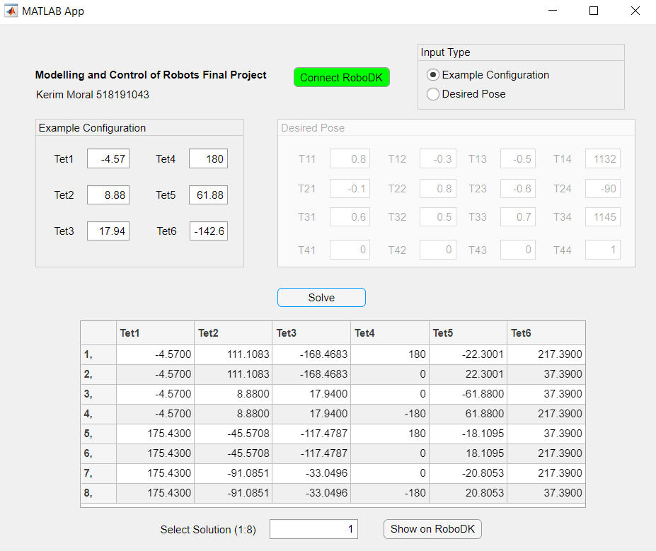

Figure Example Configurations

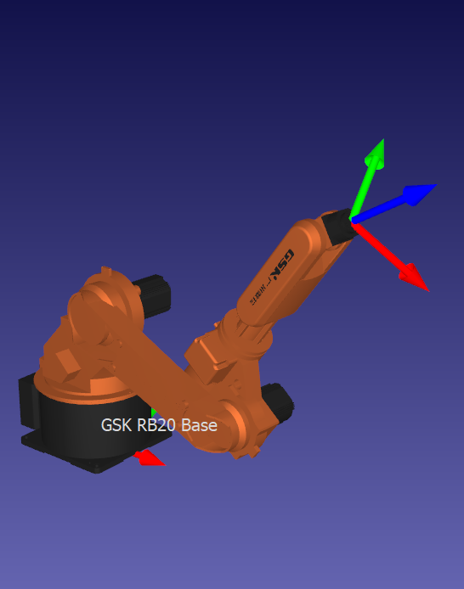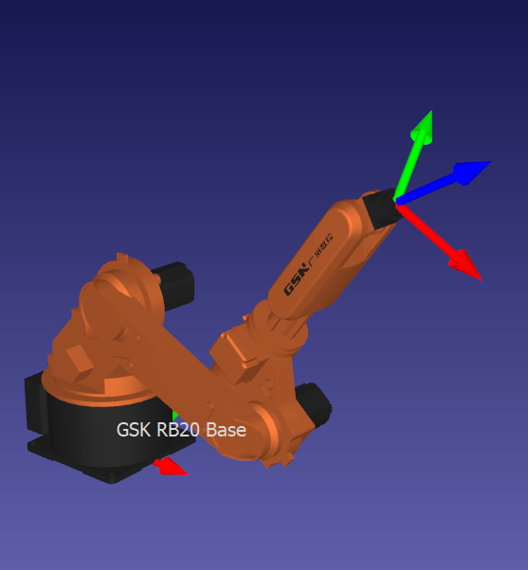

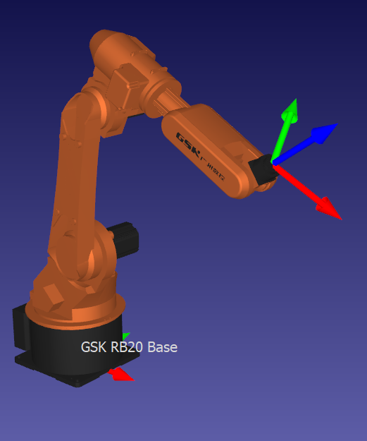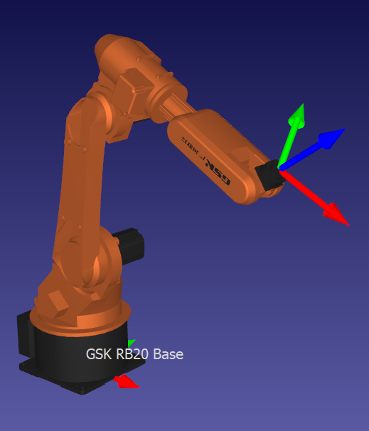

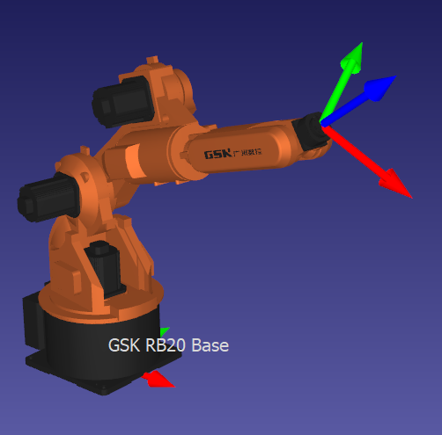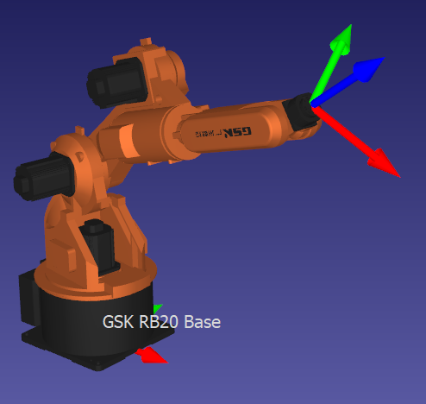

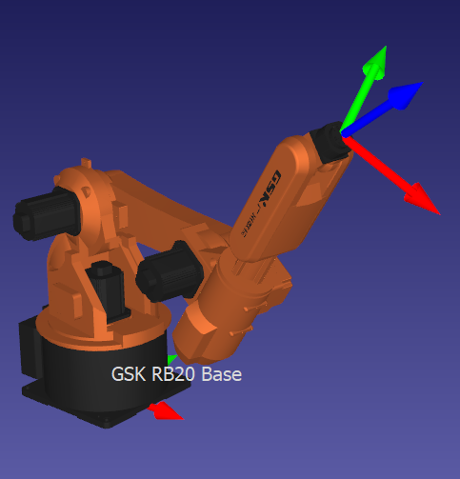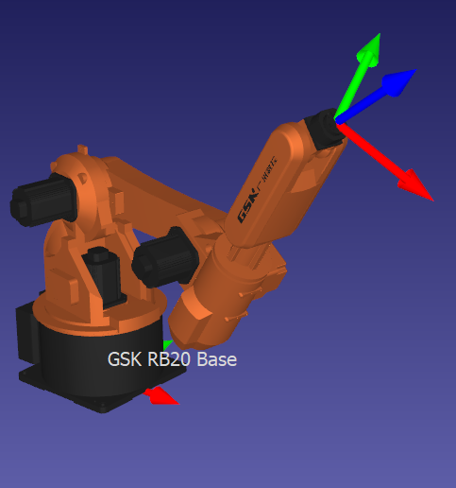

Figure Configuration Test